

EVENT EMERGENCY RESPONSE PLAN

Responsible Parties
In the event of an emergency all parties have a responsibility to ensure the safety of people and protection of property. This Emergency Response Plan outlines actions to be taken by the International Centre (the “Centre”) and by the The National Franchise Show.
Event Management (the “Client”) must make an announcement to advise attendees at the beginning of the event of the emergency exits and give a brief description of the fire alarm system. It is also advised that the Client should plan for lost children, altercations, unruly patrons, safe and secure handling of cash, picketing, etc.

In the event of an emergency – Key Contact Numbers- listed in order of priority
- Call 911 and your on-site First Aid provider (if applicable)
- International Centre Client Services 416-891-2505
- Security 416-676-6573
In the event that Client Services or Security is unreachable, please call Carraway Inc. to assist in routing the emergency vehicles to the appropriate entrance.
- Carraway Inc. 416-723-0451

Action Plan for Medical Emergencies
- Immediately contact 911 and your Event’s First Aid Service provider (if applicable)
- Notify the Centre’s Client Services (416-891-2505).
- Notify your Event’s Security to assist in the situation. List number here:
- Submit a copy of an incident report prepared by your Event’s First Aid Provider or your Event’s Security to the Centre’s Client Services and/or Security department.

Action Plan for Fire/Explosion Emergencies
- Client Services in conjunction with the Centre’s Security will be the primary facilitators in the investigation of, and the response to, a fire and/or a fire alarm situation.
- Client Services will go directly to the affected area. All emergency announcements will be made by the Centre’s Security, and the Event will no longer have access to the public announcement system.

Emergency Alarm System: The International Centre has a two stage alarm system.

Stage One Alarm:
Hall 1, 2, 3, 4, 5 & 5A: The lights/strobes will flash on and off and then the horns will blow intermittently throughout the affected halls.
Hall 6: Horns will blow intermittently throughout the affected halls. There are no lights/strobes.
Conference Centre: The lights and strobes will flash on and off. There are no horns.

Causes for a Stage One alarm are:
- Smoke Detector has been activated.
- Sprinkler System or fire hose has been activated.
- Emergency Pull Station has been activated.

- The initial announcement made by the Centre’s Security for all Stage One alarms:
Attention, Attention Please. There is an alarm condition in (Specify Area). The alarm is being investigated. Please standby for further instructions.

Stage Two Alarm:
Hall 1, 2, 3, 4, 5, 5A & Conference Centre: Horns will sound a three pulse temporal (a faster intermittent alarm in three pulse clusters) throughout the affected halls and the lights/strobes will continue to flash.
Hall 6: Horns will sound a three pulse temporal (a faster intermittent alarm in three pulse clusters) throughout the affected halls. There are no lights/strobes.
- The Stage Two alarm is only activated on the specific orders of the Centre’s Client Services or Engineering personnel, the Fire Department, or it will engage automatically after the stage one alarm has been activated for 5 minutes.
- If a Stage Two alarm sounds, it will be verified by Building Services that the alarm is authentic.
- If the alarm is authentic, the following announcement will be made by the Security Officer: “Attention Please, Attention. Please stop what you are doing and leave (Specify Area or All buildings) by the nearest exit in an orderly fashion. We request that you leave the building now as a precautionary measure. We will inform you when it is clear to return”.
- Immediate evacuation must take place at the commencement of Stage Two Alarms.
- If an evacuation is necessary, please refer to the attached site plan to locate your Designated Evacuation Area. Primary/Secondary and Security contacts for the Event should go to the designated area and wait for a Centre representative to update on the situation.

In the case of a Fire Emergency in your Event Space
- If an unmanageable fire/explosion occurs or there is an imminent threat of personal injury, then the nearest Emergency Pull Station should be activated and 911 should be called immediately. Notify Client Services by using the contact information listed above and describe and identify the location of the problem.
- If a small fire is discovered or there is the presence of smoke, notify Client Services.
- If there is a fire and it intensifies before a representative from the International Centre arrives, please activate the nearest Emergency Pull Station.

In the case of a Power Failure, Flood, or Gaseous Odor
- Notify the Centre’s Client Services immediately.
- Describe and identify the location of the problem.
- Assign one of your Event staff to attend the location of the problem if it is safe to do so.
- Event management will be kept informed of the situation by Client Services staff.
- In the event of a power failure emergency lights will activate automatically. These lights will provide minimal lighting to assist in leaving the affected area safely.
- Additionally, the Centre has back-up generators which will be activated automatically after the power failure.
- The main Hall lights will be back at full power within 10-15 minutes after a power failure. Power to individual booths and/or power supported to equipment on the exhibit floor will not be available until the main public utility power supply has been restored.
- The following announcement will be made in the case of a power failure
Attention, Attention Please. We are experiencing a power failure. Emergency lights have been activated. Within 10-15 minutes the International Centre’s emergency power back-up system will reactivate the main Hall lights. Exhibitor power will not resume until full public utility power is restored. There is the possibility of power surges when full power is restored. Please switch off any electrical equipment now including computers and/or monitors to avoid damage to equipment.
- You will be advised when electrical equipment may be turned back on.

In the case of Bomb or other Telephone Threats
- Place the Bomb Threat form (attached) in a location that is easily accessible to your Show Office telephone, and advise your staff that this form should be used in the case of a threat.
- The person receiving the threatening call should remain calm and listen to the caller without interrupting.
- Obtain as much information as possible about the implied threat. Use the Bomb Threat form as a guideline.
- Notify Client Services.
- Show Management, Events Management, International Centre Management and your Event Security will meet to discuss what action, if any, will be taken.
- Keep the information regarding the threat on a “need to know basis” to avoid unnecessary concern.

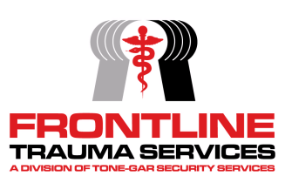
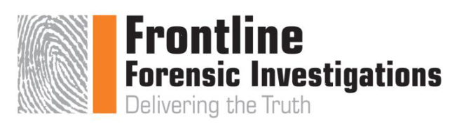
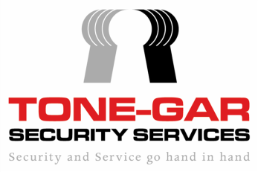
Bomb Threat Check List

Time: ____________ Date: _____________________

- When is the bomb going to explode? ___________________________________

- Location of bomb: _________________________________________________

- Description of Bomb:________________________________________________

- What type of Bomb / when will it explode? ______________________________

______________________________________________________________________

- What will cause it to explode? _________________________________________

- Did you place the bomb? _____________________________________________

- Who are you? ______________________________________________________

- How can I reach you if we get disconnected? ____________________________

______________________________________________________________________

Notes/Comments: ____________________________________________________________________

____________________________________________________________________

Caller information:

Sex of Caller: Male / Female Approx. Age: _____________________

Phone number caller is calling from: _________________________________________

Exact wording of Threat: __________________________________________________

______________________________________________________________________

Phrases or Common words used:
______________________________________________________________________

______________________________________________________________________

Callers voice: (circle any / all that apply).

Calm Clearing Throat Stutter Slurred Nasal

Slow Disguised Deep Lisp Distinct

Loud Deep Breathing Angry Ragged Soft

Normal Rapid Accent Crying Familiar

Raspy Laughter Excited Cracking High Pitch

Well spoken Foul (language) Irrational Incoherent Scripted

Other: ____________________________________________________

Background Sounds:

Street Noise Traffic No Noise persons dogs

PA system Music Aircraft Machinery static

Long distance Clear Confined Space Echo Construction

Train/station Bus/station Wind Rain Thunder

Other:
_______________________________________________________________________

Report call Immediately to:

Name: ____________________ Time________ Via: _______________

Name: ____________________ Time________ Via: _______________

Name: ____________________ Time________ Via: _______________

Address (location of incident / City / street / Name)
______________________________________________________________________

Location which you answered the call: ___________________________
Other Comments: _________________________________________________________

_________________________________________________________

Your Name (Print): _________________________________________________________

Signature: _________________________________________________

Supervisor Signature / Date: ___________________________________

Incident Report Number: ____________________

Emergency Response Plan Acknowledgment & Key Contacts
[Please complete and return a signed copy to Eunice Chan.]

Event Name: The National Franchise Show

Primary Contact:
On-site Telephone Number:
Cell Phone Number:

Secondary Contact:
On-site Telephone Number:
Cell Phone Number:

Event Security Company Contact:
On-site Telephone Number:
Cell Phone Number:

I acknowledge that I have received a copy of the International Centre’s Emergency Response Plan and have reviewed the plan with a representative of the International Centre while on site. I also agree to inform and instruct our Event personnel and volunteers to ensure that they are aware and have an understanding of the plan.

National Event Management Inc.,

Dina Latina
Primary Contact Name Date

Primary Contact Signature

