C o u n t y o f F a i r f a x , V i r g i n i a
To protect and enrich the quality of life for the people, neighborhoods and diverse communities of Fairfax County

Guidelines for Sampling at Temporary Events: Farmers Markets, Fairs, Conventions, and Festivals
Sampling: A food product promotion where only a sample of a food is offered free of charge to demonstrate its characteristics. A sample cannot be a whole meal, an individual hot dish or a whole sandwich. Not applicable if vendor is conducting a cooking demonstration booth and offering samples of cooked food e.g. cooked chicken to demonstrate a skillet or knife.
No permit for sampling is required if the following conditions are met:

- A maximum of only six (6) products are being sampled at a time:
  - A product made by mixing two or more primary ingredients (i.e., a dip made by mixing dried herb packet with sour cream, olive oil mixed with dried herb packet, etc.) will count as one product.
  - A variety of one type of manufactured, packaged food product (i.e., baked goods, candies, jellies, jams, salsas, honey, etc.) will count as one product.
  - A variety of the same type of cut fruit or vegetables (i.e, samples of different varieties of apples or peppers) will count as one product.
- All department SANITATION REQUIREMENTS are being followed.

SANITATION REQUIREMENTS:

- All food being sampled must be from an approved source. Processed foods must be manufactured in or purchased from a licensed food establishment or processing facility. To verify an approved food source, the Health Department may request copies of retail food establishment permits, food manufacturer licenses, and/or receipts showing date of purchase.
- All fruit and vegetables must be washed under running potable water prior to cutting. Washing removes dirt, soil, and any other contaminants.
- A three-compartment washing station is required. Use this setup to wash, rinse, and sanitize knives, cutting boards, and other multi-use equipment and utensils used to prepare and handle food products.
- Food handling at the event requires easy access to a handwashing sink or a handwashing station that consists of:
  - a 5-7 gallon container equipped with a hands-free dispensing valve
  - a 5 gallon catch basin for wastewater
  - potable water
  - liquid hand washing soap in pump or squeeze bottle
  - paper towel supply for the entire day.
- Wash hands prior to handling food products and then frequently throughout the event, especially any time hands are contaminated and between glove uses. After shaking patrons’ hands or handling money, hands must be rewashed before handling food products.

Page 2 of 5

- There can be no bare hand contact when working with food products. Obtain disposable gloves for use when cutting and handling products. Do not reuse gloves after touching contaminated surfaces or money.
- Obtain sampling containers with sneeze and handling protection.
- Use toothpicks, wax paper, paper sampling cups, tongs, or disposable utensils to distribute samples. This is to prevent patrons’ hands or fingers from touching the samples or contaminating the food.
- All samples (including the original source container) may only be used for a length of four (4) hours during a single event. All unused samples (including the original source container) must be disposed of after four (4) hours.
- Use a plastic bag lined waste basket to collect and discard waste from food preparation and patrons.
- Know where toilet and “greywater” dumping facilities are located for proper discard of wastewater from food preparation and hand washing. Do not empty wastewater on the ground or pavement or down a storm drain.

Fairfax County Health Department Division of Environmental Health Consumer Protection Program
10777 Main Street, Suite 100, Fairfax, VA 22030
Phone: 703-246-2201 TTY: 711 Fax: 703-385-9568
www.fairfaxcounty.gov/hd

Page 3 of 5

Required items for proper sampling

Top left to right: Waste basket with liner, disposable latex or plastic gloves

Bottom left to right: disposal single-use utensils, covered sampling container, tongs, knife and cutting board

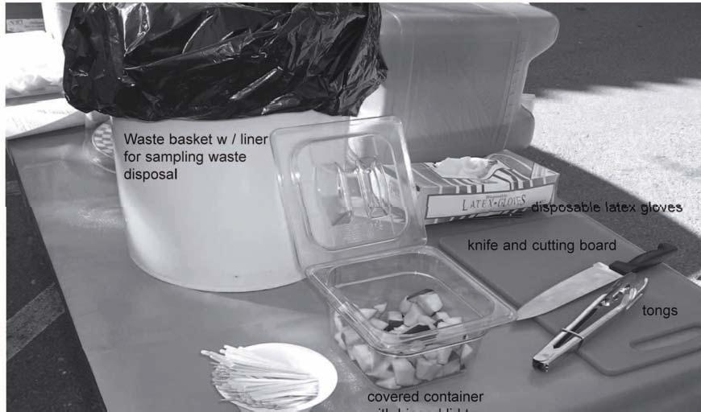

Fairfax County Health Department Division of Environmental Health Consumer Protection Program
10777 Main Street, Suite 100, Fairfax, VA 22030
Phone: 703-246-2201 TTY: 711 Fax: 703-385-9568
www.fairfaxcounty.gov/hd

Examples of Fairfax County Health Department approved sampling methods

Provide containers with hinged covers to prevent food contamination.
Use of tongs to give out sample.
This method provides the best way to keep the food samples from being contaminated. Vendor is in complete control of the sampling process. This method is highly recommended.

Here is another example of how to protect your samples. Notice the samples have tooth picks already so customer does not have to touch the sample. Cake cover acts as a sneeze protector.
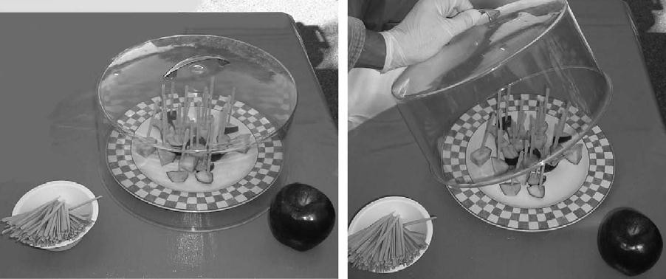

If you are sampling nuts of any kind, you must use a nut-shaker similar to the ones pictured.

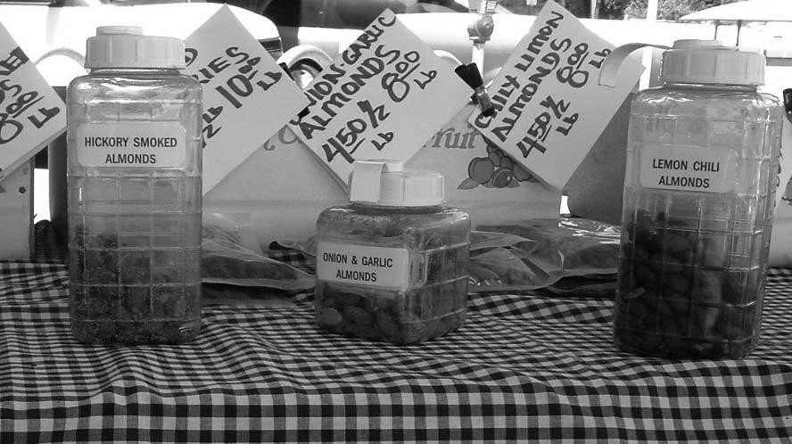

A temporary hand washing station must consist of, at least, running water, soap, paper towels, a discard bucket and trash can. If a sink is not available, a large thermos or container in which water is held for dispensing for hand washing can be used. The container must have a spout that allows the water to remain running without holding or pushing the dispensing mechanism. A container needs to be placed under the water container to catch the wastewater. As a food vendor you must provide this set up in your stand.
