Temporary Food Establishments Requirements & Information Packet
Fairfax County, VA
CARNIVALS, FAIRS, FESTIVALS, AND OTHER EVENTS
This packet includes the following information:
- Permit Application Process, including timelines & fees
- Requirements for Temporary Food Permits
- Application
All vendors who wish to prepare and serve food to the public during a temporary event in Fairfax County, City of Fairfax, and Falls Church must have a permit issued by the Fairfax County Health Department. Vendors are required to apply online and pay any required application fees to obtain the Permit to Operate a Temporary Food Establishment and are subject to a Health Department inspection. During events, vendors are required to post their permit from the Health Department and follow all food safety guidelines pursuant to Chapter 43.2, Fairfax County Food Code.

TEMPORARY PERMIT APPLICATION PROCESS

A Temporary Food Establishment is a type of food establishment that operates for a period of no more than 14 consecutive days in conjunction with a single event or celebration, including carnivals, fairs, festivals, and other events. A temporary food establishment includes at least [one of] the following:
- A food establishment with a current and valid Permit to Operate issued by the Fairfax County Health Department. The food vendor remains subject to inspection by the Health Department; however, the Health Department will allow the establishment to operate under their existing Permit to Operate. The owner/operator must post in public view a copy of their Permit to Operate at the point of food service on their stand/ booth. There will be no assessment of an additional application fee to operate as a food vendor;
- A restaurant with a food establishment permit or license issued by a health jurisdiction other than Fairfax County that is participating as a food vendor;
- A firm that is under an inspection program conducted by the Virginia Department of Agriculture and Consumer Services (VDACS) offering unpackaged samples of their product, including cutting or slicing produce items at a farmer’s market; (See Sampling Guidelines)
- A gourmet food vendor who offers unpackaged samples of their product to the public; (See Sampling Guidelines)
- A mobile food unit without a permit issued by the Fairfax County Health Department;
- A demonstration cooking booth where samples are offered to the public; and
- A restaurant that donates or sells food to a 501c3 organization.
- An organization that does not meet tax-exempt status (501c3), whether sponsoring or participating as a vendor in an event.
- Please contact the Health Department at 703-246- 2201 if you are not sure your operation meets the definition of a temporary food establishment. (For a list of exemptions to these requirements, please refer to Title 35.1-25 of the Code of Virginia: § 35.1-25. Exemptions
The Event Coordinator is responsible for organizing the event and provides food vendors with the “Requirements for Temporary Food Establishments”. Event Coordinators submit an application to the Health Department online at PLUS - Accela Citizen Access(2) (fairfaxcounty.gov)

THE EVENT COORDINATOR WILL PROVIDE A LIST OF PARTICIPATING FOOD VENDORS WITH CONTACT INFORMATION FOR EACH VENDOR THROUGH THE APPLICATION PROCESS IN PLUS.
- The Event Coordinator can request food vendor training as part of their application in PLUS but will be responsible for contacting the Health Department to determine if there is a training requirement prior to the event. Advance notice of at least 2 weeks must be given to schedule training.

Temporary Food Vendors are required to submit applications to the Health Department online at PLUS - Accela Citizen Access(2) (fairfaxcounty.gov) along with any required application fees.

The completed application and fee must be received at least ten (10) days prior to the event. Upon completion and submission of the application in PLUS, the applicant is acknowledging an agreement to comply with applicable requirements.
- If operating out of a commissary or restaurant, please include the name and location of the facility
being used on the application. Please note that a vendor who uses a commissary or restaurant as a base of their food operation is more likely to be issued a permit to operate prior to the event.
- Permits are not transferable to another food vendor or event and are valid only for the period of time specified.
- Only those food items listed on the application may be offered for sale, sample, or service unless changes are approved in advance by the Health Department.
- Temporary food establishments shall not open for business until a permit has been issued.

REQUIREMENTS FOR TEMPORARY FOOD ESTABLISHMENTS

The following requirements are pursuant to Chapter 43.2, Fairfax County Food. These requirements address the safe handling, pre- paration, transportation, storage and protection of food items prepared and served to the public from temporary food establishments at such events as carnivals, fairs, festivals, and craft shows.
The purpose of the requirements is to reduce risk factors known to contribute to foodborne illnesses associated with temporary food establishments. Risk factors include improper personal hygiene, inadequate cooking temperatures, improper holding temperatures, and unapproved food and water source. Inspections of the temporary food establishments are conducted by the Health Department to ensure that the operator has implemented control measures to reduce and/or eliminate the conditions associated with these risk factors.

Note: the Applicant shall comply with all requirements of the Fairfax County Health
Department. If violations are found, the operator must take corrective action immediately or as directed by the Health Official. Failure to correct the violation(s) will result in the revocation of the Health Department Permit and immediate cessation of the food service operation. Failure to comply may also affect Health Department issuance of a permit at future events.

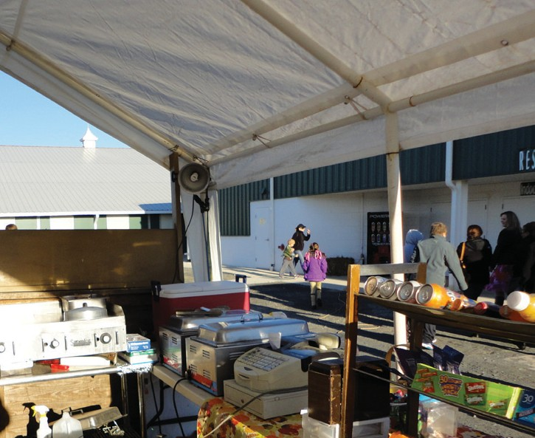
PHYSICAL FACILITIES:
- Food booths shall have overhead protection and a cleanable floor surface. The preferred floor surface is asphalt or concrete; however, plywood, tarp or a similar non- slip surface may be used if the booth is located on grass, loose gravel or dirt. Overhead
protection where there is cooking must be approved by the Fire Department.
- An adequate supply of potable water must be available at each booth. Water must be from an approved source.
- Containers with tight-fitting lids shall be provided for liquid waste. Wastewater (i.e. wash water, rinse water, sanitizing water, drained ice water, etc.) may not be disposed of on the ground surface. Sewage connections shall be sanitary, non-leaking, inaccessible to insects and rodents, and approved by the health department prior to the event.
- Adequate and sanitary toilet facilities must be available and conveniently located for food employees.
- The person in charge is responsible for keeping the preparation and service areas and the surrounding grounds free of litter, trash and garbage. All garbage/refuse shall be containerized and properly disposed of during and after the event.

PERSONAL HYGIENE:
- Persons having open cuts or sores on his/her hands or arms may not prepare or serve food.
- Persons with acute respiratory infections such as colds or flu, or persons with communicable diseases involving organisms that can be transmitted by food are not allowed in food service operations and are subject to immediate exclusion if found handling food in a temporary food establishment.
- No eating, drinking, or smoking shall take place in the food preparation area, serving area, or cleaning and storing area of a temporary food establishment.
- Hands must be washed frequently and fingernails kept trimmed and cleaned. A container with a spigot containing water from an approved source must be provided for hand washing with a separate container to catch wastewater. Liquid hand soap and paper towels must be provided. Gloves or chemically treated hand wipes (hand sanitizers) are not a substitute for handwashing.

Food handlers that use the toilet facilities, smoke, eat or drink must wash their hands before returning to work.
- Hair restraints are required for all food handlers. Hair nets, caps, visors, etc., are acceptable means of hair restraint.
- The outer garments of food handling employees shall be clean. Jewelry should be limited. Excessive hand jewelry may not be worn.

FOOD AND BEVERAGE:
- All food products including beverages, ice and water shall come from an approved source. The use of HOME CANNED or HOME PREPARED FOOD is strictly prohibited.
- A vendor who uses an approved commissary or restaurant to store and prepare food items is more likely to be issued a permit to operate prior to an event.
- Food temperatures shall be maintained safe for perishable (potentially hazardous) foods as follows:
  - Cold foods - maintain food temperature of 41°F or below.
  - Hot foods - maintain food temperature of 135°F or above.
  - Food in transit must be protected from contamination and must meet the temperature requirements noted above.

Note: Sufficient equipment is essential for cooking foods and maintaining temperatures of all perishable foods (i.e. steam tables, chafing dishes, refrigerators, ice chests, etc.)
- Temperature Control for Safety (TCS) foods that have been cooked, cooled and refrigerated must be reheated
for hot holding to 165°F within 2 hours.
- Foods shall be stored at least six (6) inches off the floor.
- The manager, operator, or person in charge shall provide and use a properly calibrated metal stem bayonet thermometer or digital thermometer with a range of (0-220°F) in +/-2°F increments for checking internal food temperatures. The thermometer shall be properly sanitized prior to each use and periodically calibrated.
- Food and utensils must be protected from contamination.
- Ice for human consumption shall be stored in cleanable, covered, self-draining containers and dispensed with handled scoops, tongs, or other approved methods.
- Food condiments such as mustard, catsup, relish, etc. must be served in individual packets, squeeze bottles, or pump type dispensers. Cream and sugar shall be served in individual packets only. Milk products shall be refrigerated to 41°F or below. In instances where dispensers or individual packets are not available, food handlers must add condiments or ingredients requested by the patron.
- Foods that are contaminated, adulterated in any way or held at improper temperature are subject to immediate condemnation and discarding.

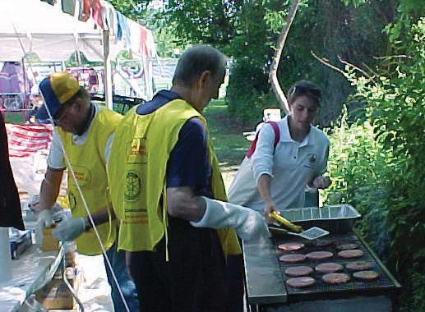

FOOD PREPARATION, HANDLING, DISPLAY AND SERVICE:
- Bare hand contact with ready- to-eat foods is prohibited. Provide disposable gloves, tongs, spatula, tissue paper or other utensil(s) for use to prevent bare hand contact with ready-to-eat foods.
- Food preparation is to be kept to a minimum and prepared in small quantities.
- Food preparation and cooking must be separated from public access.
- Adequate counter protection devices (sneeze guards or shielding) must be provided to protect non-packaged displayed foods from contamination.
- Packaged food shall not be stored in contact with water or undrained ice.
- Toxic items such as cleaners must be labeled and stored away from food and food preparation surfaces.
- An adequate number of leakproof and flyproof garbage containers shall be provided and serviced as needed. Plastic garbage bags should be used to line the garbage containers. Arrangements must be made for clean-up and final disposal of all solid waste.

EQUIPMENT AND UTENSILS:
- Sufficient cold and/or hot holding facilities shall be provided which are capable of maintaining TCS foods at proper temperature of 41°F or below and 135°F or above. Ice chest with adequate ice may be used for keeping foods cold.
- Storage containers, single service items, equipment and utensils shall be stored at least six (6) inches off the floor or ground surface.
- Only single service utensils may be provided for use by the consumer. If wrapped single service utensils are not provided, then the utensils must either be handed to each consumer by the food worker, or stored in a manner where the food contact surface is not exposed and handles are presented to the consumer.
- Hoses used for potable water must be food grade and labeled to indicate that
they are commercial grade or NSF approved. Back-flow prevention devices must be provided also if deemed necessary.
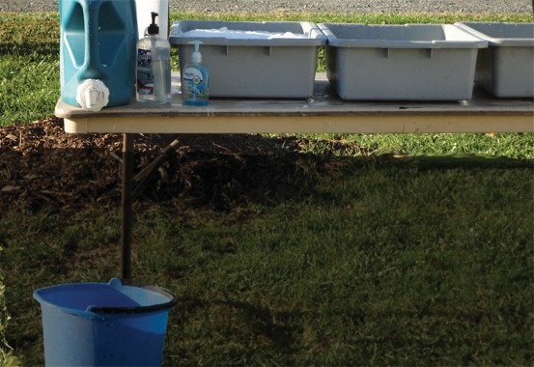

- Three containers of adequate size shall be provided for washing, rinsing and sanitizing food contact surfaces of equipment and utensils.
- Equipment and utensils shall be cleaned and sanitized after each possible contamination (i.e. dropped on ground, working with different products, etc.).
- Appropriate test strips shall be provided by the operator or person in charge and used to check sanitizing concentration strengths.

Fairfax County Health Department 10777 Main Street, Suite 111
Fairfax, VA 22030
703-246-2201, TTY 711
Food Safety | Health (fairfaxcounty.gov)

A publication of the Fairfax County Health Department, Fairfax County, Va. Apr. 2015. To request this information in an alternate format, call 703-246-2411; TTY 711; www.fairfaxcounty.gov/health.

